Golden Arrow Menu
BREAKFAST

Bucks fizz
Bluebell smoothie
Orange juice
Apple juice

-O-

Granola with Morello cherry, passion fruit parfait

-O-

Croissant, Danish pastries

-O-

Dry cured bacon
Cumberland sausage
Scrambled egg
Black pudding
Rosti potato
Portabello mushrooms
Grilled beef tomato
Baked beans

For the vegetarian breakfast, bacon will be substituted with grilled haloumi
and sausage will be substituted with a vegan sausage

-O-

Tea or coffee

Golden Arrow Breakfast Menu – Dishes and their allergen content
Dishes | 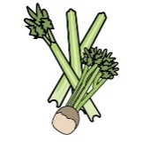 | 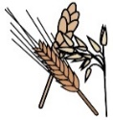 | 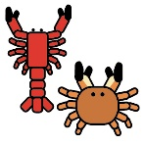 | 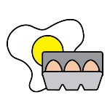 | 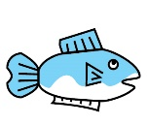 | 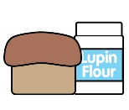 | 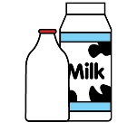 |  | 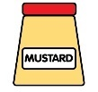 | 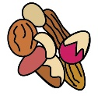 | 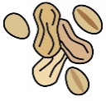 | 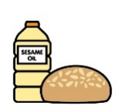 |  | 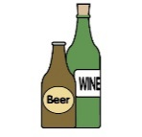
A ✓ indicates the allergen is present. | Celery | Cereals containing gluten* | Crustaceans | Eggs | Fish | Lupin | Milk | Mollusc | Mustard | Nuts† | Peanuts | Sesame seeds | Soya | Sulphur Dioxide
Bluebell smoothie
Granola with Morello cherry, passion fruit parfait |  |  |  |  |  |  | ✓ |  |  | ✓
Croissant |  | ✓ wheat |  | ✓ |  |  | ✓ |  |  |  |  |  | may contain
Danish pastry |  | ✓ wheat |  | ✓ |  |  | ✓ |  |  | may contain |  |  | ✓
Scrambled egg
Dry cured bacon
Cumberland sausage |  | ✓ wheat |  |  |  |  |  |  |  |  |  |  |  | ✓
Black pudding |  | ✓ barley & oats
Rosti potato
Portabello mushrooms
Grilled beef tomato
Baked beans
Grilled haloumi
Vegan sausage
Whilst every effort is made in our procedures, all our products are made in a kitchen that handles celery, cereals containing gluten, crustaceans, eggs, fish, lupin, milk, mollusc, mustard, nuts, peanuts, sesame seeds, soya and sulphur dioxide and may contain traces.

