Golden Arrow Menu
MARCH - MAY

Baby leek and puy lentil soup
with garlic and herb croutons
(vegetarian, vegan, dairy free, gluten free)

Chicken liver and brandy parfait
with Morello cherry gel and brioche thins

Potted crab with lemon butter
endive salad and grilled sourdough

-O-

Roasted sirloin of Sussex beef
with Yorkshire pudding and rich red wine gravy
(gluten free Yorkshire on request)

Pot roasted breast of cornfed chicken
with smoked bacon lardons, roasted baby vegetables and Madeira jus
(gluten free)

Roasted beetroot wellington
with fine green beans and fondant potato
(vegetarian, vegan, dairy free)

-O-

Tarte au citron

Chocolate cappuccino mousse
(vegetarian, vegan, dairy free, gluten free)

Selection of Sussex cheeses with biscuits and quince jelly
available as an alternative to dessert for £9 or as an extra course for £12
(gluten free on request)

-O-

Coffee and truffles

Golden Arrow March - May Menu – Dishes and their allergen content
Dishes | 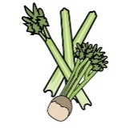 | 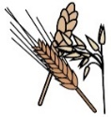 | 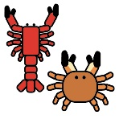 | 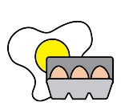 | 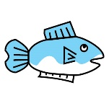 | 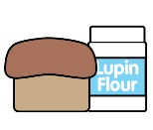 | 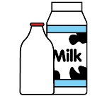 |  | 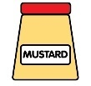 | 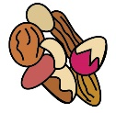 | 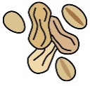 | 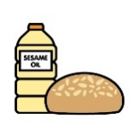 |  | 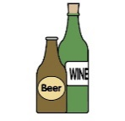
A ✓ indicates the allergen is present. | Celery | Cereals containing gluten* | Crustaceans | Eggs | Fish | Lupin | Milk | Mollusc | Mustard | Nuts† | Peanuts | Sesame seeds | Soya | Sulphur Dioxide
STARTER
Baby leek & puy lentil soup with garlic & herbs croutons | ✓
Chicken liver & brandy parfait, with Morello cherry & brioche thins | ✓ | ✓ wheat |  | ✓ |  |  | ✓
Potted crab with lemon butter, endive salad and grilled sourdough |  | ✓ wheat | ✓ |  |  |  | ✓ |  | ✓
MAIN
Roast beef
Yorkshire pudding |  | ✓ wheat |  | ✓ |  |  | ✓
Beef gravy |  |  |  |  |  |  |  |  |  |  |  |  |  | ✓
Pot roasted breast of Cornfed chicken with smoked bacon lardons | ✓
Chicken gravy |  |  |  |  |  |  |  |  |  |  |  |  |  | ✓
Horseradish sauce |  |  |  | ✓ |  |  | ✓ |  | ✓ |  |  |  |  | ✓
English mustard |  | ✓ wheat |  |  |  |  |  |  | ✓
Roasted beetroot wellington |  | ✓ wheat |  |  |  |  |  |  |  |  |  |  | ✓
DESSERT
Tarte au citron |  | ✓ wheat |  | ✓ |  |  | ✓
Chocolate cappuccino mousse |  |  |  |  |  |  |  |  |  |  |  |  | ✓
Cheeseboard | ✓ | ✓ wheat |  |  |  |  | ✓ |  | ✓ |  |  |  |  | ✓
Truffles |  |  |  |  |  |  | ✓ |  |  | May contain |  |  | ✓
Whilst every effort is made in our procedures, all our products are made in a kitchen that handles celery, cereals containing gluten, crustaceans, eggs, fish, lupin, milk, mollusc, mustard, nuts, peanuts, sesame seeds, soya and sulphur dioxide and may contain traces.

